Best Buy Strategy Management
MGMT 590 - Strategy Management

Mukerji, Chiranjiv
Shiach, Euan
Surapolchai, Promporn
Szafron, Jessica
Wu, Meng-Yin Monica
Yang, Chao-Yu

Best Buy is the largest electronics retailer in the US. In recent years the direct competition in the form of Circuit City has been removed and yet stock prices continue to fall. Why? Bad strategy. Management has looked to restructuring of the big box stores for salvation and the analysts aren’t buying. They’ve seen this approach from Best Buy before and been disappointed. The definition of insanity is doing the same thing over and over and yet expecting different results. Through our strategy proposal the wrongs will be righted and previous failures corrected. Best Buy will compete with Amazon for the first time and stop surrendering market share. There is life in the old dinosaur yet, and we will show you where, how, and when.
Contents
1. Existing Marketplace……………………………………………………………………........3
1.1. Company Overview…………………………………………………………………3
1.2. Current Financial Overview…………………………………………………….3
1.3. Understanding the Marketplace……………………………………………..7
1.4. Current Marketing Mix………………………………………………………….10
2. Current Operations…………………………………………………………………………..12
3. Strategy Recommendations……………………………………………………….……..14
3.1. Improving the Website………………………………………………………….14
3.2. Stop Expanding Big-Box Stores……………………………………………..16
3.3. The Right Restructure…………………………………………………………..18
4. Summary…………………………………………………………………………………………..20
5. Works Cited……………………………………………………………………………………...21

Existing Marketplace
Company Overview
Best Buy Co., Inc. (NASDAQ: BBY) together with its subsidiaries is one of the world’s leading companies that operates as a retailer of consumer electronics, home office products, entertainment software, appliances and related services in the United States, Canada, China, Europe and Mexico. It controls retail stores and websites under 11 brand names: Best Buy, Five Star Appliances, Future Shop, Geek Squad, Magnolia Audio Video, The Carphone Warehouse, Best Buy Mobile, Audiovisions, Napster, Pacific Sales and Speakeasy. Its stores sell a variety of electronic gadgets, movies, music, computers, mobile phones, and appliances. On the services side, it offers installation and maintenance, technical support, and subscriptions for mobile phone and Internet services. Best Buy currently has about 167,000 employees worldwide (Source: Hoovers, Best Buy Co., Inc. Profile).
Current Financial Overview
Believing that past performance is only a base to future success and not a guarantee due to changing market conditions, we need to analyze Best Buy’s current financial strategy and strength by looking at some of its key indicators over the past 5 years. Specifically we will look at historic and current Revenue, Net Income, Net Profit Margins, along with the number of Employees on staff:
Table 1: Financial Overview
Year | Revenue ($ M) | Net Income ($ M) | Net Profit Margin | Employees
Feb-12 | 50,705.00 | -1,231.00 | -- | 167,000
Feb-11 | 50,272.00 | 1,277.00 | 2.54% | 180,000
Feb-10 | 49,694.00 | 1,317.00 | 2.65% | 180,000
Feb-09 | 45,015.00 | 1,003.00 | 2.23% | 155,000
Feb-08 | 40,023.00 | 1,407.00 | 3.52% | 150,000
Feb-07 | 35,934.00 | 1,377.00 | 3.83% | 140,000
(Hoover's, 2012)

Figure 1: Financial Overview
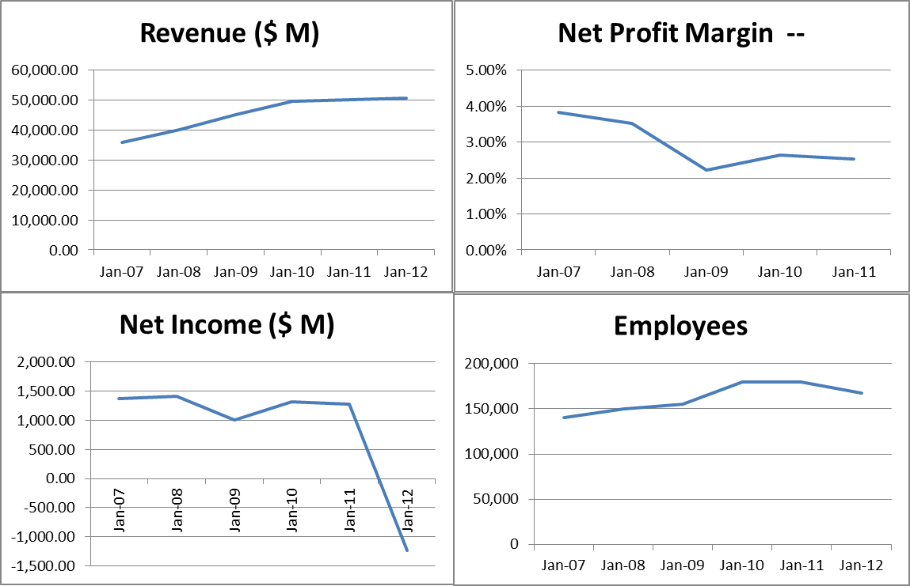
(Hoover's, 2012)
In fiscal 2012 Best Buy reported a net loss of $1.2 billion compared to net earnings of $1.3 billion in fiscal 2011. The 2012 net loss was primarily due to the buyout of Best Buy Mobile for $1.3 billion, which gave it full ownership of the fast-growing US mobile phone joint venture from British partner The Carphone Warehouse (TCW). Revenue in 2012 increased only about 2% over the prior year because of the net addition of 235 new stores in fiscal 2012, an extra week of revenue from domestic and Canadian stores, and favorable currency exchange rate fluctuations (Hoover's, 2012).
Through analyzing 5 years of financial data, we see that even with aggressive expansion, Best Buy has only seen a marginal growth in revenue and Net income. Furthermore there has been a continuing decline in the net profit margin and that has only begun to level off in the last 2 years. The small increase in revenue was partially offset by a 1.7% decline in comparable store sales.

Figure 2: Revenue Mix

(Buy, 2012)
Please note the Consumer Electronics (including TVs, DVD players, and audio systems) and Home Office (computers, tablets and mobile phone products) together generated 72% of Best Buy's sales for the year in both the domestic and international segments (Buy, 2012). The Appliances (including Kitchen Cookers, Refrigerators, and Washing Machines) only contributed 6% to revenues in comparison.
Best Buy has grown over the years through acquisitions and that continues to be a key component of its strategy today. Best Buy has expanded its customer reach within the US market through acquisitions that provide it greater access to new types of customers. The company has also expanded into international markets (Canada, China, Europe) over the years and Best Buy’s international business is expected to be increasingly important going forward. Most of these acquisitions have been carried out using cash due to positive cash flows from operations. This ensures that the company utilizes its excess cash and manages its debt capacity. Best Buy’s debt to equity ratio of 54.15% is relatively high compared to the selected competitors. Only Wal-Mart had a higher debt to equity ratio at 72.69%. The primary reason that Best Buy’s debt to equity ratio is higher than its competitors is due to its aggressive expansion plans (Investopedia, 2011).
The company reported pre-tax restructuring charges totaling $222 million in 2011 (Buy, 2012). These charges are towards plans to restructure its international operations in order to enhance returns and to drive supply chain efficiencies in its Domestic segment. These restructuring costs are yet to show their effects on either the top-line as well as the bottom line for best buy.
In 2012, Best Buy announced $800 Million Multiyear Cost Reductions by fiscal 2015 in order achieve higher efficiency and to lower its cost base (Buy, 2012). Some specific actions intended to lower costs are expected to include the closure of 50 U.S. Best Buy big box stores in fiscal 2013, cost savings in corporate and support structure from IT services savings, procurement savings on non-merchandise purchases, a reduction in outside consultant services and reduction of approximately 400 positions in our corporate and support areas. Savings in cost of goods sold driven by reduction of product transition costs, lower product return and exchange expenses and supply chain efficiencies.
Reemergence of Richard Schulze
A key management development in 2012 saw Best Buy founder Richard Schulze leave the organization he founded 40 years ago. However, within 2 months of his departure, he was granted access to perform certain due diligence along with private equity sponsors in furtherance of making a fully financed proposal to re-acquire Best Buy. Richard Schulze is the company's largest shareholder with a 20% stake in Best Buy (Buy, 2012). With the prevailing negative market sentiment on Best Buy and its current business model, Schulze’s return has raised questions affecting stock performance. Through our analysis we have determined that this buy back should be resisted. Other than the CEO’s being out of a job, there is no competitive advantage in taking the company private. Schulze has not publically provided a strategy to turn around a company that has steadily declined over the last several years under his watch. There exists a new generation of retailers competing both online and in brick and mortar outlets that were previously foreign to Schulze. We don’t believe 2 months off has brought any insight or clarity to the situation. In addition, Schulze disagrees with current cost restructuring strategies and has been verbally unwilling to reduce in size big box stores which continue to hemorrhage cash. Finally, if a pleasing strategy is announced to the public and Schulze pulls a 180 on the approach to restructuring, well then the question of funding still remains. Schulze’s capability for funding $8.8 billion is not clear and could simply be a strategy to distract management.
Management Restructuring
As part of the departure of Schulze and restructuring of the management team, there have been two key acquisitions: Hubert Joly and Sharon McCollam. Very recently, Best Buy named Carlson executive Hubert Joly as chief executive, hoping to tap his expertise in restructuring companies to turn around the world's largest consumer electronics chain. Joly is credited with the successful restructuring of several A list companies such as Vivendi and EDS. To further enhance restructuring expertise, Best Buy hired former Williams-Sonoma Chief Financial Officer Sharon McCollam as CFO. As the world's largest consumer-electronics retailer seeks to reduce its store count and strengthen its online operations McCollam’s experience will be invaluable. While at Williams-Sonoma, McCollam helped reduce the San Francisco-based home-goods retailer's square footage 7 percent from 2008 to 2011 while boosting sales 11 percent. Williams-Sonoma started several e-commerce websites while McCollam was CFO and chief operating officer and improved its supply chain both of which are key strategy suggestions for Best Buy.

Share Repurchase and Dividends
In June 2011, the Board authorized a new $5.0 billion share repurchase program. In fiscal 2012, Best Buy repurchased and retired 54.6 million shares at a cost of $1.5 billion, while they repurchased and retired 32.6 million shares at a cost of $1.2 billion in fiscal 2011. We believe this strategy should be continued as it will help Best Buy in three ways: Increase Earnings Per Share, Maintain a lean cash position, and provide tax-efficient distribution of earnings. Firstly, when a company repurchases its own shares, it reduces the number of shares held by the public. The reduction of the float, or publicly traded shares, means that even if profits remain the same, the earnings per share increase. Secondly, Best Buy with its strong cash generation can become an attractive target for takeover (i.e. Schulze), since the cash can be used to pay down the debt incurred to carry out the acquisition. The share repurchases bolster the stock price, making a takeover more expensive and therefore less likely. Finally, Share repurchases also allows companies to covertly distribute their earnings to investors without inflicting them with taxation which is an efficient method of overall tax reduction and easy way to build loyal, long-term investors.
In regards to dividends the board of directors of Best Buy regularly authorizes payment of a cash dividend. The company has 336,529,732 shares of common stock issued and outstanding as of August 4, 2012. This once again is an indication of healthy cash flow (Buy, 2012). For investors the cash dividend is a source of attraction and comfort.
Understanding the Marketplace
Rivalry Among Existing Competitors
Since the liquidation of Best Buy’s direct rival Circuit City in 2009, Best Buy has acquired a relatively high level of internal rivalry from many indirect competitors in the consumer electronics industry. The top fifty companies account for seventy percent of sales in the industry, making the consumer electronics market relatively concentrated (Hoover's, 2012). Best Buy’s competition main competition can be divided up into four major categories. These include direct retail competitors such as Circuit City (out of business), RadioShack, and hhgregg, discount retailers such as Costco, Wal-Mart, and Target, online retailers such as eBay.com and Amazon.com, office supply stores such as Staples, Office Depot, and Office Max, as well as a variety of smaller retailers, such as those found online (Kwok, 2009). Home improvement stored such as Lowe’s and Home Depot can also be considered as its own distinct competitor group, but will be neglected here since appliance sales do not make up a significant portion of sales for Best Buy.
Three of Best Buy’s largest competitors currently include Wal-Mart, Apple Inc., and Amazon.com (Hoover's, 2012). Apart from competitors such as hhgregg, it is difficult to compare Best Buy to many of these indirect competitors because many of them carry a substantial variety of products outside of the realm of consumer electronics and appliances and therefore cannot be broken down according to the sales of different product categories. For example, in 2011, Wal-Mart’s annual sales were $446.95 billion, followed by Apple at $108.25 billion, then by Best Buy at $50.71 billion, and finally by Amazon.com at $48.08 billion (Hoover's, 2012). Even if the sale of consumer electronic products accounted for only a small percentage of Wal-Mart overall annual sales, it would still be a significant number, particularly considering they, like Amazon.com and many others, are not solely in the retail electronics industry. In addition, it is important to note that the consumer electronic and appliance products found at Best Buy and amongst its competitors are not differentiated. In other words, consumers can find similar if not identical products at any of these stores or retailers. As such, retailers must compete in other areas, such as customer service and price (Kwok, 2009). Furthermore, it is a well-known fact that consumers use consumer electronic stores such as Best Buy to physically see and test a product prior to ordering that product online at a typically cheaper price. Thus, competition between online and brick and mortar retailers is becoming increasingly fierce.
Threat of Substitute Products
Because Best Buy’s products consist mainly of consumer electronics and home appliances, there is a very low threat that there will be substitute products that will take market share away from this retail market. There is ever increasing reliance on technology and electronic products in today’s market, and according to USA Today, the popularity of smartphones and consumer tablets alone is dramatically boosting sales in the consumer electronics industry. Sales of consumer electronics are predicted to grow by 5.9% in 2012 from the previous year to over $200 billion. Furthermore, according to the Association of Home Appliance Manufacturers (AHAM), nearly every household in the U.S. owns a refrigerator and stove, and with many others also owning washers and dryers (Hoover's, 2012). Thus, it is unlikely a substitute product will take the place of these products in the near future. In terms of consumer electronics, if looking at these products from the point of viewing as being leisure time products, only a few substitute products would be even remotely considered threats such as books, magazines, and possibly even outdoor equipment. If this were the case, then retailers such as Barnes and Noble, Borders, and Dick’s Sporting Goods would represent the largest threat. However, there are currently no products that can serve as direct substitutes for electronics and appliances at the current point in time.
Threat of New Entrants
The overall threat of new entrants for Best Buy can be considered fairly low. The most notable threats of new entrants that exists is manufacturer stores opening up that directly sell the manufacturers’ consumer electronics, with the major point in case being Apple, who has rose to become one of Best Buy’s largest competitors in recent years. Other notable threats include the threat of other retail giants beginning their own consumer electronics departments, as major retailers such as Wal-Mart and Costco has also proved in recent years, as well as the potential threat of mail order retailers. Although these threats are of course not negligible, they should not be considered major reasons for concern at the current point in time. The main reason for this has to do with significant barriers to entry, such as the large amount of up-front capital needed to enter the market, technological needs, as well as the fact that the consumer electronics is a fairly saturated market with major competition as it is, making it difficult for a new up and coming company to compete. In terms of direct brick and mortar new entrants in particular, the barriers to entry can to considered to be significantly high because of the massive overheard and property costs alone. Thus, for the threat of new entrants that does exists, that threat would most likely come from internet based retailers. Finally, another factor that can be viewed as an additional barrier to entry is the reputations that new entrants would have to build in order to compete with current competitors (Kwok, 2009). Reputation is a significant factor to consider when discussing the sales of often high-priced consumer electronics and appliances, and is definitely something that retailers such as Best Buy, Wal-Mart, Apple, and Amazon.com have established for themselves over the years in the eyes of the consumer.
Bargaining Power of Suppliers
Since there are many suppliers in the industry, including major manufacturers such as Samsung, Toshiba, Sony, and Panasonic, Best Buy needs to purchase these suppliers’ products in order to stay competitive and satisfy its customers. Best Buy relies heavily on suppliers due to the fact that 39% of Best Buy merchandises come from five major suppliers, which are Apple, Samsung, Hewlett-Packard, Sony, and Toshiba. Although Best Buy is a major player in consumer electronic, there are many retailers such as hhgregg, RadioShack, Wal-Mart and Target, including online retailers such as Amazon and eBay, that are also rely on these suppliers that implies low switching cost of suppliers. Moreover, though Best Buy offers its house brand such as Insignia TV, Best Buy still has a limited ability to do backward integration since it requires a huge capital and technological expertise. This means that suppliers have high bargaining power over Best Buy.
However, even though most of consumer electronic suppliers have their own stores and also online stores, they still need retailers to store their products on shelves (Kwok, 2009) because retailer is the most effective channel for customers to see and test the electronic products. Additionally, Best Buy is one of major players in the industry; it has over 1,000 stores in US and over 2,000 international stores, Best Buy purchases significant proportion of products from suppliers. If suppliers increase their prices or reduce product quality, they will lose a lot of revenues from Best Buy. Consequently, the overall bargaining power of suppliers in consumer electronic retail industry is moderate.
Bargaining Power of Buyers
For Best Buy, most of all the consumers are direct consumers that are weak and fragmented. (Kwok, 2009) A buyer’s purchase volume is usually low. Since Best Buy has a large number of consumers, it does not depend on each one of the consumers. Losing one of the customers will not affect its revenue. Therefore, no buyer has any particular influence on products or prices. Furthermore, Best Buy product represents only a small expense for its consumers. They will not put any effort negotiating with the retailer to lower price and have a competition between them for the product. Buyers have no ability to integrate backward because there is impossible for them to build their own electronic consumer retailers or produce their own electronic products. All these suggest that buyers have very low bargaining power.
On the other hand, there are some factors that increased the bargaining power of consumers. Due to a lot of consumer electric retailers in the market, including discounted retailer and particularly online retailers, buyers, which usually are price sensitive and concern about product quality, have more options to choose where to buy. Consumers will find the possible lowest price and purchase the product there since Best Buy’s merchandises are undifferentiated from competitors’. It is easy for consumers to switch to competitors’ products, which means they have low switching cost. Hence, the bargaining power of buyers in the consumer electric market is moderate due to the fact that a stronger competition between retailers within the industry has increased the bargaining power of buyers.
In the case of Best Buy as a buyer of consumer electronic product, Best Buy is considered a retailer rather than individual. Best Buy has higher bargaining power over suppliers because Best Buy’s purchases from suppliers are relatively large portion of suppliers’ business. Losing one retailer consumer like Best Buy is definitely critical to them. There are also many choices of suppliers for Best Buy to purchase. Although Best Buy loses some bargaining power to suppliers due to more intense competition between retailers, it still has strong and positive relationship with suppliers and is able to negotiate for price and product quality.
Current Marketing Mix
Product
Best Buy is a multi-brand store that carries most major brands across the following categories Consumer electronics (TVs, DVD players, and audio systems) and Home Office (computers, tablets and mobile phone products), Entertainment/Software (DVD’s, Games, utility software’s) & Appliances (Washers, Dryers, Refrigerators). As previously highlighted, Consumer Electronics & Home Office contribute 72% of total revenue while appliances contributing approximately 6% of total revenue (Buy, 2012). Best Buy generally focuses on offering a broad selection of brand-name products to consumers. Major suppliers include Apple, Samsung, Hewlett-Packard, Sony, and Toshiba, which together account for 40% of total merchandise purchased by Best Buy (Hoover's, 2012).
Promotion
Best Buy ranks as the 56th-largest advertiser in the U.S., with $666.5 million ad spending, including both measured and unmeasured media, according to Ad Age's Datacenter (www.adage.com, 2010). Best Buy has adopted a customer centric approach where it has taken time to understand its customers and their needs and then started selling solutions instead of products. As part of its research, Best Buy has discovered that 55 percent of its customers were women, and that for the most part they loathed their shopping experience at the retailer. Men look for a specific product at a discount price. Women want not just a digital camera, but a printer, cable, and other accessories--and they care far more about these things than price. Equally important, they want help with installation, while most men prefer to try to put things together themselves. Best Buy's concept of customer centricity was configuring its stores to serve the needs of the particular customer segments that predominated in the area of each store.

Price
Best Buy is unlikely overcome its pricing disadvantage. Best Buy, with its higher cost structure, cannot compete on price. With the proliferation of technology, it is easy for shoppers to find cheaper prices for Best Buy’s commodity products. Online retailers are also getting increasingly sophisticated, enabling even better online shopping experiences and faster fulfillment. Customer behavior will change to Best Buy’s disadvantage, as shoppers become more comfortable with online-only shopping. This might not matter for small items for which there might be some urgent need, but customers will surely take the time to research prices for the big ticket items upon which Best Buy’s success depends. As per the internal restructuring plans, Best Buy will ‘right size’ their stores improve cost structures. However, it will be very difficult to compete with pure online players such as Amazon.com.
Distribution
Best Buy and its subsidiaries operate more than 1,150 stores, domestically and internationally. The company operates 1,010 Best Buy Stores, 13 Magnolia Audio Video Stores (specializing in high-end electronics), 7 stand-alone Geek Squad stores, 3 Audio-Visions Stores, 13 Best Buy Mobile Stores (standalone) and 17 Pacific Sales stores (in Southern California, Arizona, and Nevada), all through the U.S. They also operate 51 Best Buy and 140 Future Shop stores throughout Canada. In addition, the company operates over 100 Best Buy Express Automated Retail stores or "ZoomShops", operated by Zoom Systems, in airports and malls around the U.S. (Buy, 2012)
Besides these traditional brick and mortar distribution channels, since 2000 Best Buy has had an online presence through bestbuy.com. The website provides customers with access to product information, product support, service packages, deals of the day etc. The website also gives customers the opportunity to order online and pick-up their products in-store. The website attracts decent number of unique visit each month - Avg. 20M visitors a month (www.compete.com, 2012).
Figure 3: Website Visitors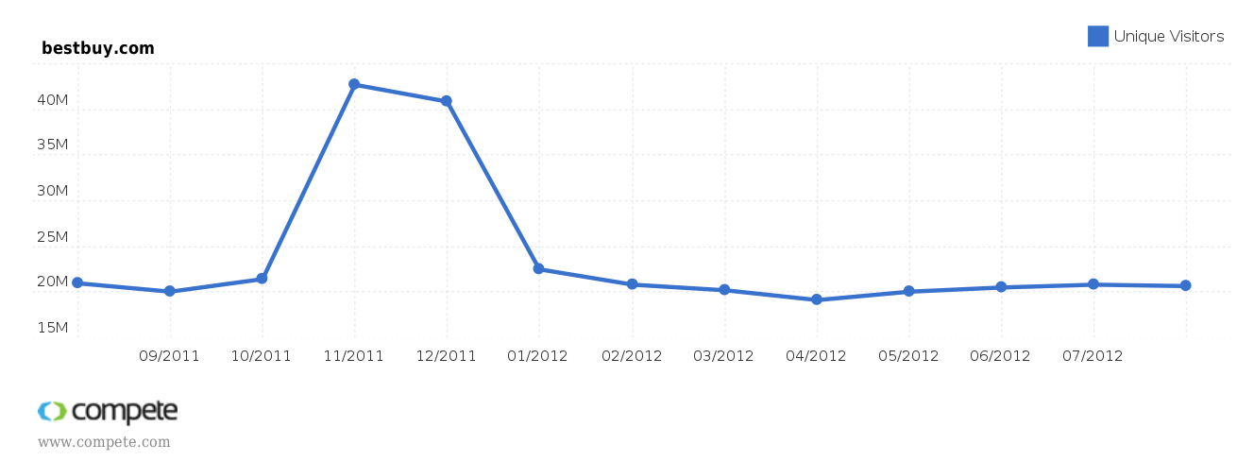

In 2003, the company opened its first international global procurement office in Shanghai, and also operates sourcing offices in Beijing and Shenzhen, primarily to reduce costs and increase the speed to market by purchasing products directly from manufacturers (Buy, 2012).
Current Operations
Big-Box Store Model
Best Buy stores operate in the form of the combination of big-box stores and chain stores. Usually, the retail stores are largely established with huge selling spaces. With the sufficient numbers and space of the stores, Best Buy can place as many as products as it could, including as many brands as possible. On one hand, by purchasing large amounts of products from its suppliers, Best Buy has the ability to lower the cost of the products it buys. On the other hand, by providing diversified products to its customers, Best Buy attracts more customers and thus generates more sales revenue. On the basis of this operation strategy, Best Buy can always offer customers with the widest range of products at the lowest price. Beside the big and mortar store, Best Buy entered the online retail business in 2000 by launching Bestbuy.com. In 2011, Best buy also opened its site to the third-party sellers to enrich the products offered (www.retailingtoday.com, 2011).
Customer-Centric Operating Model
A big part of Best Buy’s success can be attributed to the good services it provides to its customers. Best Buy was the first retail company to eliminate the commissions for the standalone sales people, providing the non-commission working environment to improve the quality of the in-store service. In 2004, Best Buy carried out its customer-centric strategy, committing to treat customers as a unique individuals and to meet customer needs with end-to-end solution. For example, each store has installation of car audio and video equipment, on-site installation services, and a Geek Squad precinct for computer repair and warranty service. This approach has differentiated Best Buy from other retail stores as providing mid to high-end electronic products with lower price while offering superior customer service at the purchase experience. The strategy sees customer service as one of the products, which is an innovative practice in the retail industry. The customer-centric concept not only generates more demands for the company, but also consolidates Best Buy’s position in the marketplace.
Rapid Store Growth and M&A Expansion
Best Buy expanded its business territory mainly by aggressive store growth and acquiring other companies. By rapidly increasing the number of stores, Best Buy reached its 1000th store by end of 2008, and became the largest electronic retail stores in the mid and eastern U.S in 2009. However, Best Buy is now trying to focus on its smaller format stores. It will close 50 U.S. big-box stores and open 100 Best Buy small-format, stand-alone stores in the current fiscal 2013. In total the company will be closing 50 stores and cutting 400 corporate jobs to reduce costs by $800 million over the next few years. In the past, store growth played an important role in generating sales revenue. By merging Future Shop Ltd., a Canada-based electronic chain store, Best Buy initially tapped into the international market in 2001. Following, Best Buy expanded its business to China by acquiring Jiang Su Five Star Appliance Co. Ltd., the fourth largest chain store in China, and tapped into European market by buying a 50% holding in the retail division of Carphone Warehouse, a UK-based cell phone company (www.en.wikipedia.org, 2012). Moreover, by acquiring companies in different industry, such as Geed Squad, Musicland, and Magnolia Audio Video…etc, Best Buy not only enriches types of its products, but also enhances the service that it provides.
Suppliers and Global Sourcing
Best Buy has many suppliers. Five of Best Buy’s largest suppliers are Apple, Samsung, Sony, Hewlett-Packard, and Toshiba, and together, they account for about 40% the merchandise. Best Buy maintains a collaborative relationship with its suppliers. In order to align with the customer-centric concept, Best Buy collects customers’ opinions and adjusts its service or strategy accordingly. Best Buy also passes those feedbacks to its vendors, so they can improve the product features to better meet customer desires. In 2003, Best Buy opened its global sourcing office in Shanghai, China. Best Buy seeks to design, develop, and expend its private-label brands to be more competitive by taking advantage of the manufacturing strength in Asia. (www.ecommercebytes.com, 2011)
Distribution
In order to meet the customer needs, Best Buy has a complicated distribution system. In the U.S, most of the merchandise are imported from Asia, and shipped directly to two consolidation centers, located in Seattle and Long Beach. And then, those “brown goods”, which includes 27-inch TVs and any goods that are smaller than that, are shipped to another 7 distribution centers around the country. Three of the 7 distribution centers serve not only the brick and mortar stores, but also the online shop. The large-screen TVs and other appliances are shipped to 14 home distribution centers to support the stores in the nearby neighborhood. Apart from that, a special logistic center in Franklin, DC, is in charged of handling the returns of all the music and movie products, both online and in-store. Other returned products go to three return centers in Pittsburgh, operated by a third-party company called Genco. (www.supplychainbrain.com, 2005) The distribution system works similarly in the international market. In China, Best Buy operates its main distribution center in Shanghai. The merchandise is directly sent to the distribution center, and then dispersed to other 50 smaller distribution centers, operated by Jiang Su Five Star Co., to serve the need all over the country.

Strategy Recommendations
Improving the Website
Blog/Customer Review
Online shoppers are increasingly relying on product reviews and buyer ratings to guide their own online purchases. Furthermore, online customer reviews as well as “shares” through social networking media can fuel additional website traffic. 44% of Moms use social media for brand/product recommendations; 73% trust online community recommendations.; 61% of people rely on user reviews for product information or research before a buying decision is made (Flannagan, 2011).
BestBuy.com has a fairly well-developed system for sharing customer reviews. Yet, it fails to give consumers the option of sharing products onto their own personal social network sites or blogs. BestBuy.com customers can participate in a ranking system that the company has established as well in which the customer gains more points as a reviewer as more people choose to share their links or like their reviews. One potential idea is to provide customers with some type of incentive system depedent on the ranking achieved in order to encourage more consumers to participate in reviewing products. The rewards can come in the form of special offers or early bird deals, and customers must continue to participate in product reviews in order to maintain or increase their reward ranking. Furthermore, customers tend to utilize the “Include Related Best Buy Products” option rather infrequently, and thus this should also be tied into this reward system based on ranking. Again, by establishing such a system, BestBuy.com can pull in a larger amount of online traffic from consumers searching for product reviews, which hopefully will translate into more online sales, particularly with the implementation of the reward system.
Larger recommendation panel
The Long Tail approach in marketing in which lesser used search phrases are utilized to drive traffic to a website is a particularly good approach in industries with strong competition and is an approach that Best Buy can utilize successfully. Best Buy currently only focuses on products within the Consumer Electronics, Home Office, Entertainment Software, and Appliances categories, but it can still find ways to expand the existing recommendation panel using a Long Tail approach. What Best Buy is currently utilizing as far as a recommendation panel goes is a relatively small “Related Products” panel that appears on a user’s page when he or she searches for or purchases any given product. Amazon, on the other hand has several more recommendation panels, including “More Search Results,” “Frequently Bought Together,” “Customers Who Bought This Also Bought,” “What Other Items Do Customers Buy After Viewing This Item,” and “Related Items.” One strategy to expand this area may be to utilize product tags as derived from customer reviews as to recommend additional products that that customer may potentially be interested in. Upgrading the quality of the product tags can not only provide consumers with more appropriate recommendations to better suit their likes, thus making them more likely to purchase additional items from the company, but they can also provide consumers with a more pleasurable overall shopping experience.
Removing Google Ads
When accessing BestBuy.com, internet users will commonly come across Google Ads displayed on the right hand side and bottom of any given page on the website. According to user’s search records, these Google Ads often provide better deals on the identical products that the user is browsing for, except that the deals are offered by competing websites. Consumers, and internet shoppers in particular, are prone to seek out the lowest possible price for any given product, particularly with the wide array of options available on the internet. Although Best Buy earns some revenue by allowing these advertisements, this does not even come close to making up for the amount of sales they may be losing on account of these ads (Google Ads on Bestbuy.com, 2010). Such an obvious strategic error could and should be easily avoided as to not quite literally hand over potential consumers to the competition. As demonstrated by the image below, one of the Google Ads that appears below an LG monitor featured on BestBuy.com directs customers to TigerDirect.com, where they can purchase the exact same product for roughly $45 less than on BestBuy.com.
Figure 4: Example of Google Ads Relocating Business
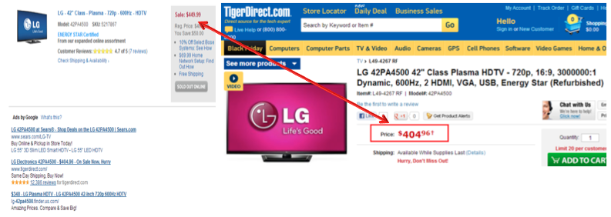
360 degree product views
One of the main drawbacks of online shopping is the fact that consumers cannot physically touch or test the product under consideration. Apart from physically going to a brick and mortar retailer to view the product, the next best option is to provide online shoppers with a 360 degree product view. Consumers should be able to not only view an image of the product up close, but also be able to rotate the item any which way they choose with the click of a mouse. The idea here is to provide online shoppers with such an experience so that they feel as if they have already interacted with and viewed the product to such an extent to which they no longer feel the need to view it in person prior to making the decision to purchase. 360 photography is know to have a significantly larger impact on consumers’ purchasing decisions compared to that of a single dimensional image due to the fact that it communicates product features more effectively and presents a higher level of information and detail to the consumer (Radulescu, 2008). Google recently launched 360 degree product views on it’s toy category only for testing during Thanksgiving, which is demonstrated in the image below. This is a concept that would also benefit Best Buy in potentially generating greater online sales.
Figure 5: 360 Product Reviews 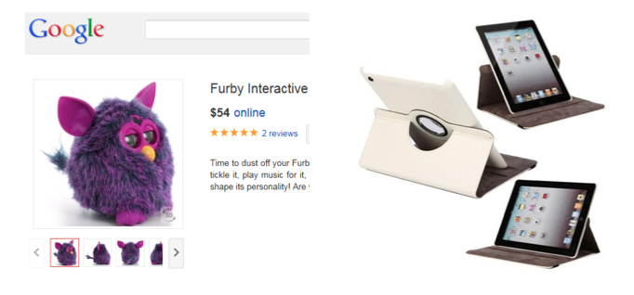
Lower Price Tag
Daily price monitoring available online allows a company such as Best Buy to have their products tagged as “Lower Price!” if their product is in fact cheaper than an identical product sold on their competitors’ websites. If BestBuy.com were to utilize this, more consumers would be attracted to the site more frequently and the website’s visibility would also increase via the online search results. The larger idea here is that Best Buy would have the advantage over its competition in that they could not only provide potential customers with the ability to view and test the product in-store, but they can also demonstrate to the consumer that their online prices are competitive with that of their online competition, hopefully making it more likely that consumers will return to the website to purchase a product after they have shopped around on other websites as well as in-store at their local Best Buy location.
Stop Expanding Big-Box Stores
The economic recession of 2008 dramatically altered the shopping and purchasing habits of many consumers. Many consumers have moved toward online shopping, in search of better deals and more convenient service than found at local stores. Unfortunately, in recent times, Best Buy brick-and-mortar locations have become synonymous with simply being showroom for consumers to physically see and test products and ask questions prior to going online and purchasing the product for a lower price elsewhere. Thus, this trend has had a significant negative impact on Best Buy’s sales, particularly with the high cost of running and maintaining brick-and-mortar stores, and the company is facing more competition than ever from areas that previously posed little to no competition for the company. Online retailers such as Amazon have become the company’s biggest competitors, and Best Buy has been struggling to compete in recent years. E-commerce now accounts for more than 20% of U.S. consumer electronics sales, and yet online sales only account for 6% if Best Buy’s domestic sales (Bloomberg Business Week, 2012).
Recent years have showed slowed growth in revenue and a decline in EPS since 2010, and yet, Best Buy has still continued to expand. By 2008, the number of Best Buy big box stores in the United States alone reached 1,000 (www.readwriteweb.com, 2012), and that number grew to 1,103 by 2012 (Hoover’s, 2012). Not only did this growth seem counterintuitive, especially in light of the fact that more consumers are moving to online shopping and away from brick-and-mortar retailers, but it also had a negative impact on the company’s financials due to the high cost of constructing and operating these stores. Best Buy suffers froma disadvantage over its competitors because of the cost of maintaining it’s stores. The company spends $6 billion on brick-and-mortar locations on a $50 billion sales base, putting the company at a 10% price disadvantage to all online competition.
Despite all this, the company has in fact recently announced plans to shut down 50 of it’s big box stores across the United States in an attempt to reduce overhead costs by $800 million by 2014 and open 100 Best Buy Mobile stand-alone stores across the country during fiscal year 2013 in order to increase business performance (bottomline.nbcnews.com, 2012). Best Buy Mobile and Online are both growing at a double-digit pace. Mobile offers lower margins, but the tremendous growth outweighs potential margin compression. Offering hot mobile items drives traffic to the stores and helps the company sell other products in addition to profiting from the devices themselves. However, it is still doubtful whether Best Buy’s competitive advantage of operating many big box stores is really an advantage at all in light of the decline of brick-and-mortar format stores and the increase in popularity of online shopping. Furthermore, though the demand for wireless products is increasing, this decision could just slow the market share losses oer the next few years due to the increasing number of wireless kiosks.
As such, it may be in the company’s best interest to consider halting the expansion of big box store locations, or at the very least, slowing down their expansion, in addition to considering an overall decrease in the square footage of their locations as well as shifting more attention to their online sales strategy. There needs to be a focus on making exisiting stores more attractive to consumers in order to draw them in, rather than just simply shutting down stores, and integrating stores with their online shopping experience. Thus, it is recommended that Best Buy should streamline it’s physical stores by reducing it’s square footage of traditional big box stores throuh store closings, subleasing, and increased small-format openings due to the fact that Best Buy must catch up with aggressive competitors such as Apple, Costco, and Wal-Mart, as well as it needs to divert this attention to the fact that more shoppers are turning to online retailers such as Amazon. The majority of the savings from cost cutting should be put toward improving customer service and reinvesting into becoming more competitive from a pricing standpoint.

The Right Restructure
Best Buy is currently pursuing a strategy in which their main objectives appear to be to close several of their big box stores and cut jobs in order to achieve a greater goal of restructuring the US electronics megalith. More specifically, “the company’s restructuring, which it began in the UK and the rest of Europe last November, includes making its stores smaller and more numerous and refocusing them on mobile communications services and devices” (Jopson, 2012). However, this is not the first time that the company has pursued such a strategy in hopes of increasing Best Buy’s overall performance, and many business analysts are skeptical as to whether such a strategy can do much to reverse the damage that has already been inflicted. Following the company’s announcement, Best Buy’s stock price dropped 7 cents to $24.77 in return (Jopson, 2012). One can define insanity as repeating the same actions over and over but expecting different results, and this is certainly one way to accurately describe Best Buy’s current strategy.
Restructing brick-and-mortar locations is an unescapable necessity, but one that should be done in way not previously seen by the analysts in the industry. It is recommended that Best Buy restructure their stores by removing large appliances and better utilizing that newly acquired extra square footage by providing a more relaxed, trendy, café type of environment that facilitates customer engagement with Best Buy’s products. This strategy would not only be aimed at improving the overall customer experience, but also to maximize the amount of time the consumer spends in the store. Furthermore, the remainder of the space would be made available to coffee retailers such as Starbucks to set up shop, thus not only attracting more customers into the store, but also generating some extra revenue by leasing the space to the coffee retailers. This strategy will require the investment of capital versus the offering of stock dividends as well as the construction of a supply chain capable of rivaling competitors such as Amazon.
The hedgehog theory tells us that we should find that at which we are best at and then be better at it than anyone else, while also making money while doing it. Unfortunately, Best Buy is struggling to accomplish the latter half of that statement, particularly in the eyes of investors, which translates to failure as a publically traded company. The topics of cash flows and the issuance of dividends will be discussed in greater detail later in this section, but it is critical to note that the company’s stock prices have been steadily falling, which is a poor omen for investors. Large appliances make up only 6% of sales for Best Buy, a very negligible percentage when considering the size and price of the products (Yahoo, 2012). Thus, the decision to eliminate large appliances should be a simple one. The return on store space to sales is simply unsatisfactory. The reason for this likely has to do with the fact that Best Buy simply cannot compete with well established appliance retailers such as Sears or with the fact that appliance manufacturers are increasingly choosing to sell their products directly to customers while bypassing any intermediary retailer such as Best Buy. Through a simple poll conducted with peers and classmates, not a single individual stated that Best Buy was a place they would consider going to to purchase their appliances. Clearly, large appliaces are not Best Buy’s hedgehog removing them will free up floor space that can be better utilized to return to what the company is good at – providing a great customer experience and selling trendy electronics.
As previously stated, it is no secret that one of Best Buy’s biggest challenges is that they supply consumers with a optimal testing ground to make future purchases. Consumers can visit their local Best Buy, feel and test products, consult with Best Buy employees on technical issues, and then return home only to make an informed purchase of that product from one of Best Buy’s competitors. Thus, it is critical that Best Buy consider ways to not only increase the amount of time a potential customer spends in their store, but also better utilize this time in such a way as to encourage on the spot purchases and discourage online purchases from competitor’s websites at a later time. Providing the potential customer with a comfortable, hands-on environment is key in this quest. It is important that the shopping experience makes the customer feel that it is vital that he or she must have the product in their hands immediately rather than in three to five business days later.
As such, it is recommended that Best Buy better utilize the void created through the elimination of large appliances by revamping the space into a inviting café environment complete with bean bag chairs where the consumer can relax and play around with one of the many electronic products offered, at their leisure. Of course, anyone can touch, feel, and test products found in any given Best Buy location at this current point in time, but by providing an area where consumers can take an iPad, comfortably sit down, and test the product over a hot cup of coffee and fluffy banana nut muffin such as depicted in the image below, the consumer can develop a far greater bond to that particular product at that particular point in time. By allowing the customer to downloand apps, update their Facebook status, and personalize their playlists in a laidback atmosphere much like the one they would experience at home, the consumer may not longer want just any iPad, but that iPad at that moment, turning the purchase into somewhat of an emotionally driven impulse buy.
Figure 6: Example of Hands On Space
Image provided courtesy of www.blogspot.com
Ultimately, Best Buy’s current supply chain model is less than impressive, particularly when compared to that of it’s main competitor, Amazon. Of course, part of the reason for this is that Amazon has very low overhead costs compared to a company such as Best Buy, and thus more cash to invest in improving their supply chain management. With just the simple click of a button, the product that the customer desires will arrive on their doorstep within a matter of days, or even less, with errors in shipment being unheard of. Product returns and exchanges are handled promptly and accurate feedback helps establish trust with consumers. Furthermore, hidden algorithms that select complementary and supplementary products help drive Amazon’s overall business model. Because Amazon is one of Best Buy’s largest competitors, Best Buy must not only be capable of competing with this model but also be capable of taking it to the next level, which may include options such as customer at-home setup of products or in-store returns. Best Buy must tackle a two-fold issue, with one side being increasing the ease and comfort of in-store purchases, and the other being competing in the domain of online shopping. It is not enough for Best Buy to just be able to compete, but rather they must be capable of carving out market share and succeeding in the online marketplace if they hope to thrive. Thus, by eliminating dividends, Best Buy can generate the fuel it needs to advance the current supply chain model and as well as excel upon the online shopping model already implemented by Amazon.
Summary
As the largest player in the US electronics market and with low competition within the sector Best Buy should be performing better and stock prices rising. Due to antiquated restructuring plans, stiff competition from online retailers, and loss of the customer experience, this is unfortunately not the case. Through restructuring the existing stores by eliminating large appliance offerings, installing comfortable, hands-on areas with coffee shops, reorganizing and prioritizing our online efforts, and slowing the growth of our big box stores, we strongly belief that Best Buy can be the best once again. Our proposal here and understanding of the market show true business sense. We have outlined funding, direction, and timing. It is up to those in charge to turn around the company and provide to investors what they should have had all along – success through capital gains.

Works Cited
www.adage.com. (2010). Market Trees 2010. From Ad Age Datacenter.
www.compete.com. (2012 йил 09-10). Best Buy Co. From Compete.com: www.compete.com/us
www.ecommercebytes.com. (2011, Sep 8). Best Buy Opens Market To The Third-Party Seller. Retrieved from eCommercebytes.
www.en.wikipedia.org. (2012). Wikipedia.
www.supplychainbrain.com. (2005). Supply Chain Brain.
www.retailingtoday.com. (2011). RatailingToday.com.
Yahoo. (2012). Best Buy. Retrieved 2012 йил 8th-October from Yahoo Finance: http://finance.yahoo.com/q?s=bby&ql=1
(2012). Retrieved from www.readwriteweb.com: http://www.readwriteweb.com/archives/readwriteweb-deathwatch-best-buy.php
(2012). Retrieved from bottomline.nbcnews.com: http://bottomline.nbcnews.com/_news/2012/03/29/10919862-best-buy-to-close-50-stores-in-restructuring?lite
Buy, B. (2012). Best Buy Fiscal Second Quarter 2013 Results. Minnesota: Best Buy.
Flannagan, R. (2011 йил 8-March). How Important Are Online Customer Reviews? Retrieved 2012 йил 8-October from Nuanced Media: http://nuancedmedia.com/how-important-are-online-customer-reviews/
Google Ads on Bestbuy.com. (2010 йил 24-06). Retrieved 2012 йил 08-10 from BBY OPEN: https://bbyopen.com/google-ads-bestbuycom
Investopedia. (2011 йил 10-11). From www.investopedia.com.
Hoover's. (2012). Best Buy Co. Inc. Profile. Hoovers.
Jopson, B. (2012 йил 29-March). Best Buy to close stores and axe jobs. Financial Times , pp. 1-2.
Kwok, D.-B. L. (2009). Strategic Report for Best Buy Co., Inc. Oasis Consulting.
Radulescu, A. (2008 йил 01-August). Increase Your Sales With 360 Degree Product View Images. Retrieved 2012 йил 08-10 from Ezine @rticles: http://ezinearticles.com/?Increase-Your-Sales-With-360-Degree-Product-View-Images&id=1375488

